SPANABANAGRAM
January 2019

December in review
December was a busy month at St. Paul Abilities Network:
- Christmas Party
- Children’s Christmas Party
- Staff Office Party
- Door Decorating Contest
- Christmas Light Contest
- Secret Santa
- Staff Appreciation Events
- Christmas Day Dinner


KUDOS
Many thanks to those who work so dilegently to plan and carry out all the special events held in December. We appreciate your efforts to make Christmas a very special time at SPAN.

DOOR DECORATING CONTEST:
And the winner is: DAC
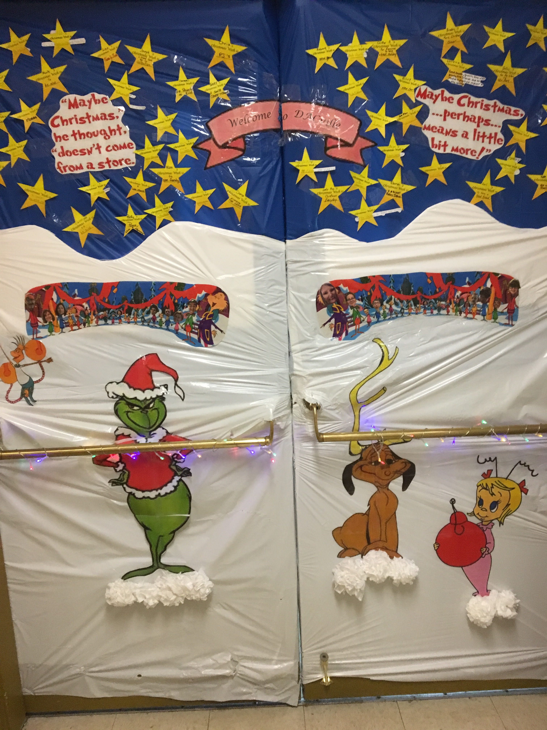
CONGRATULATIONS

Some other entries:
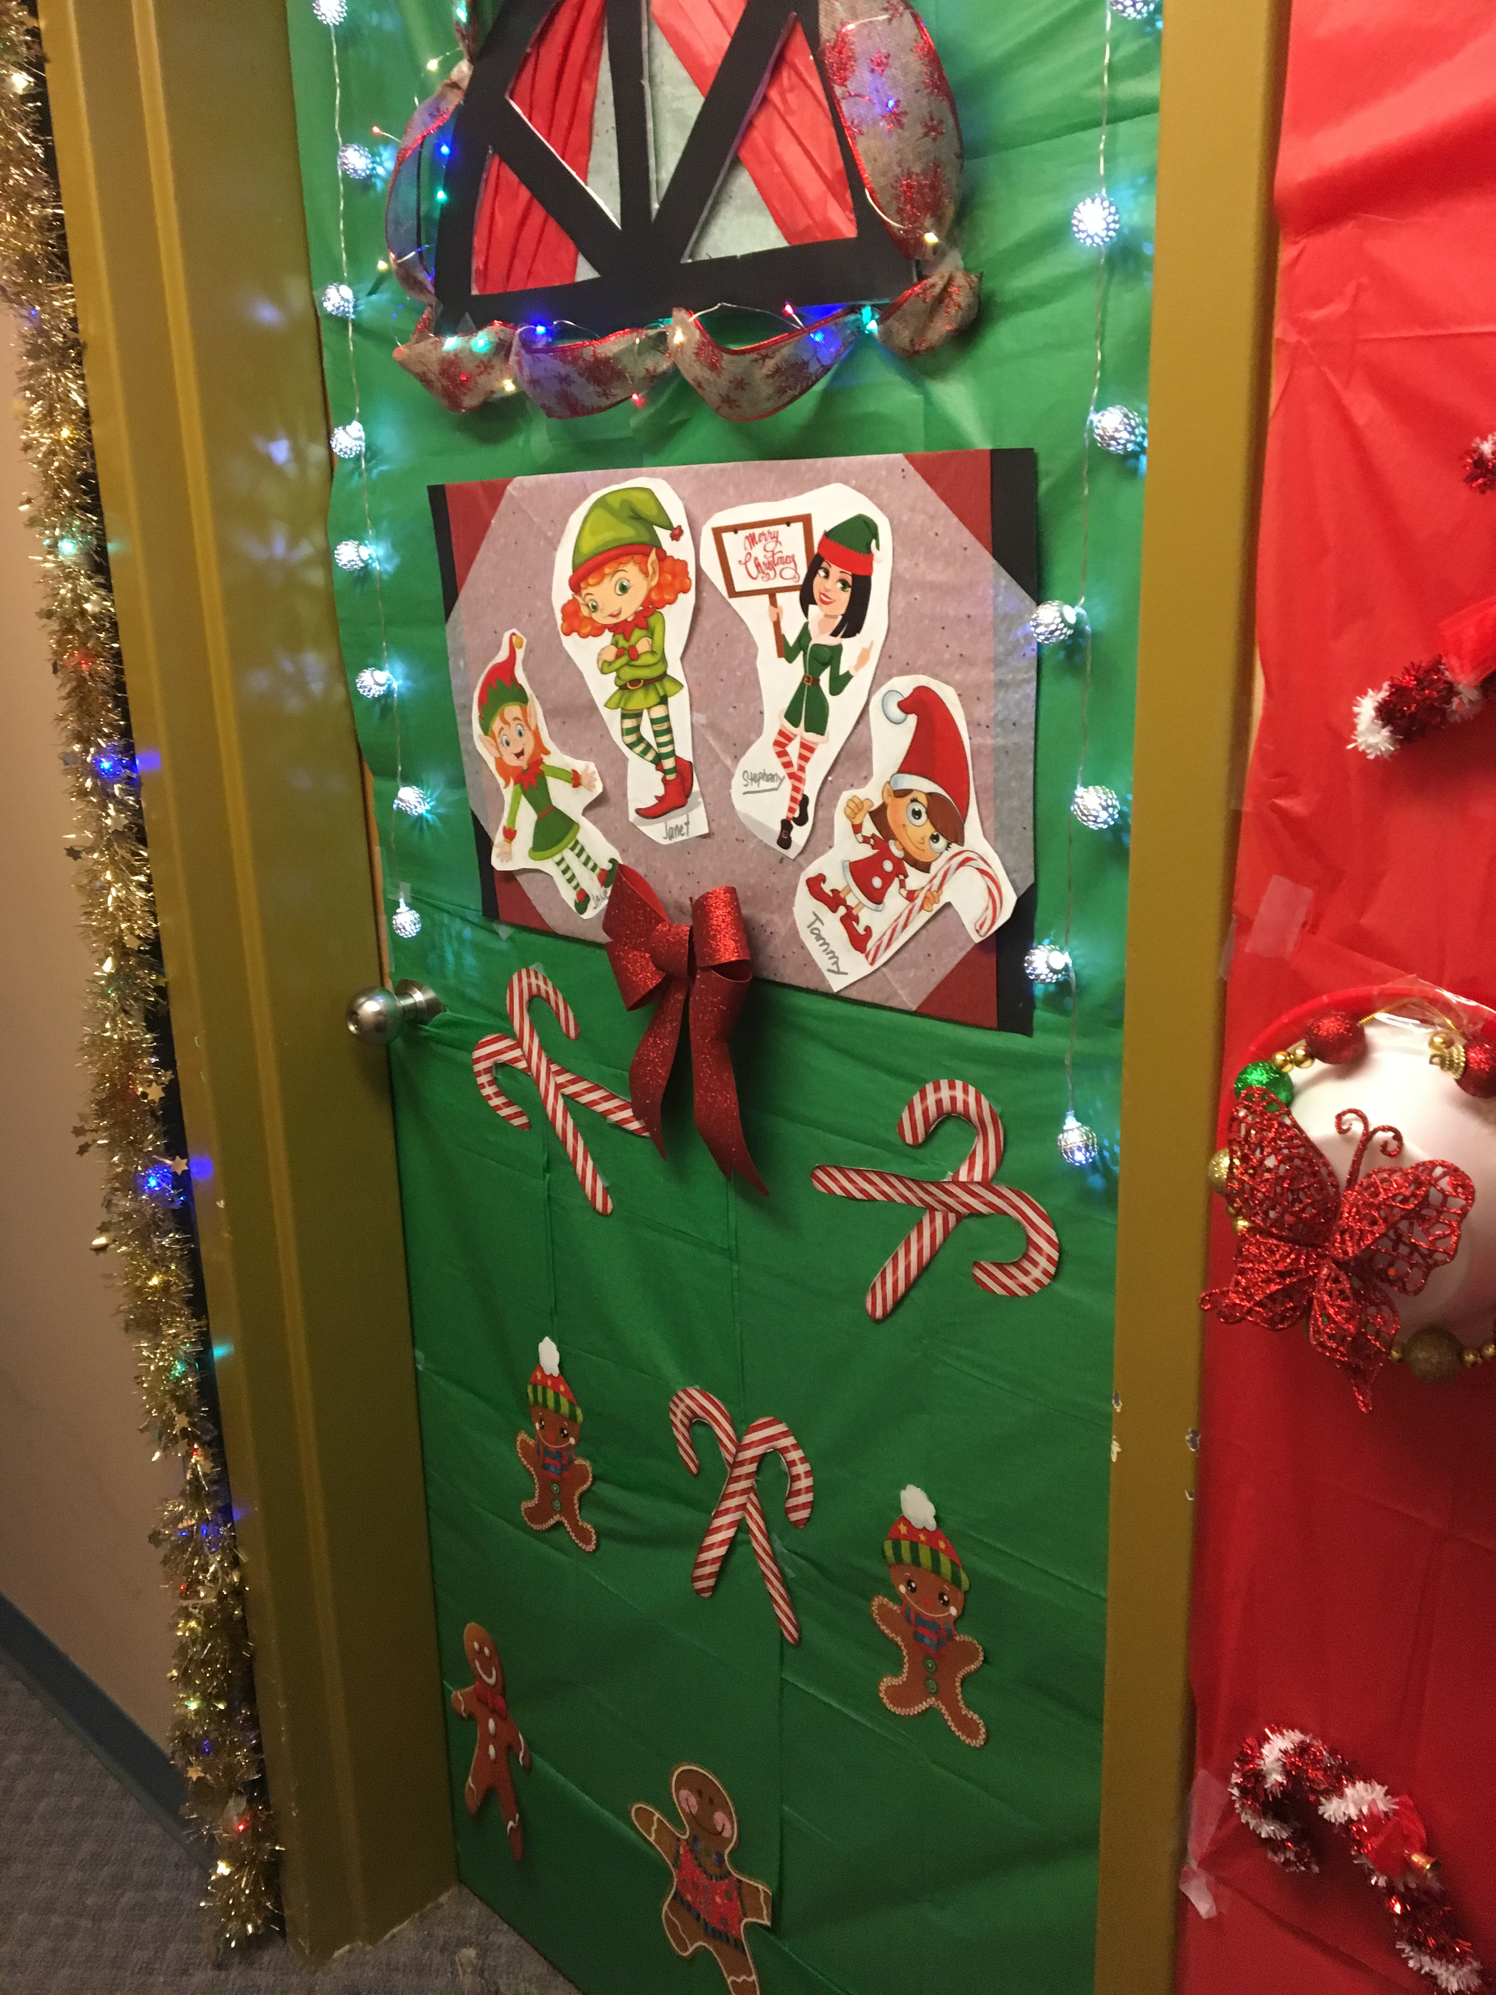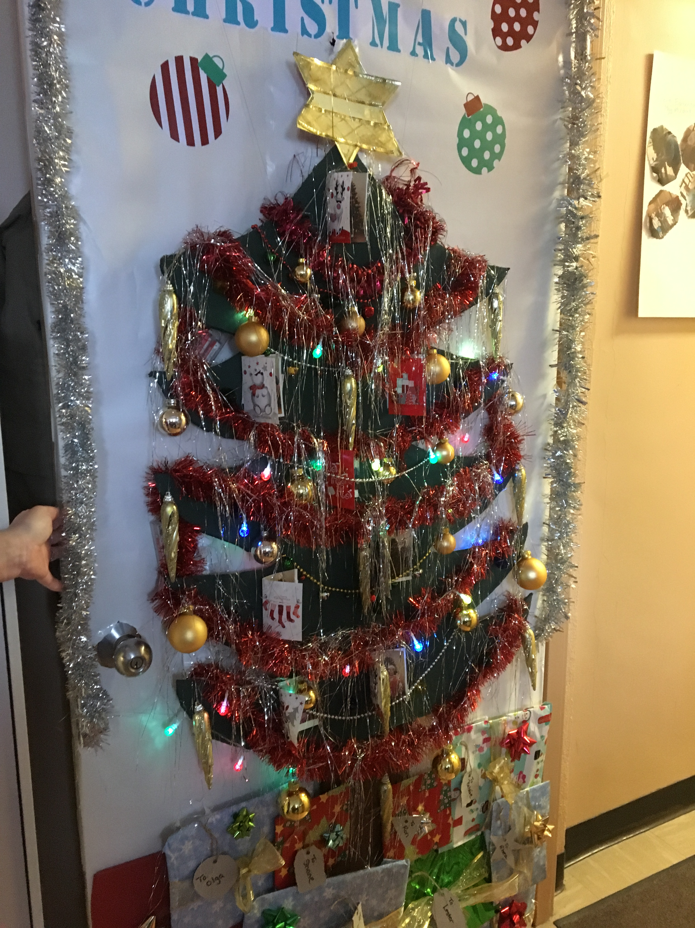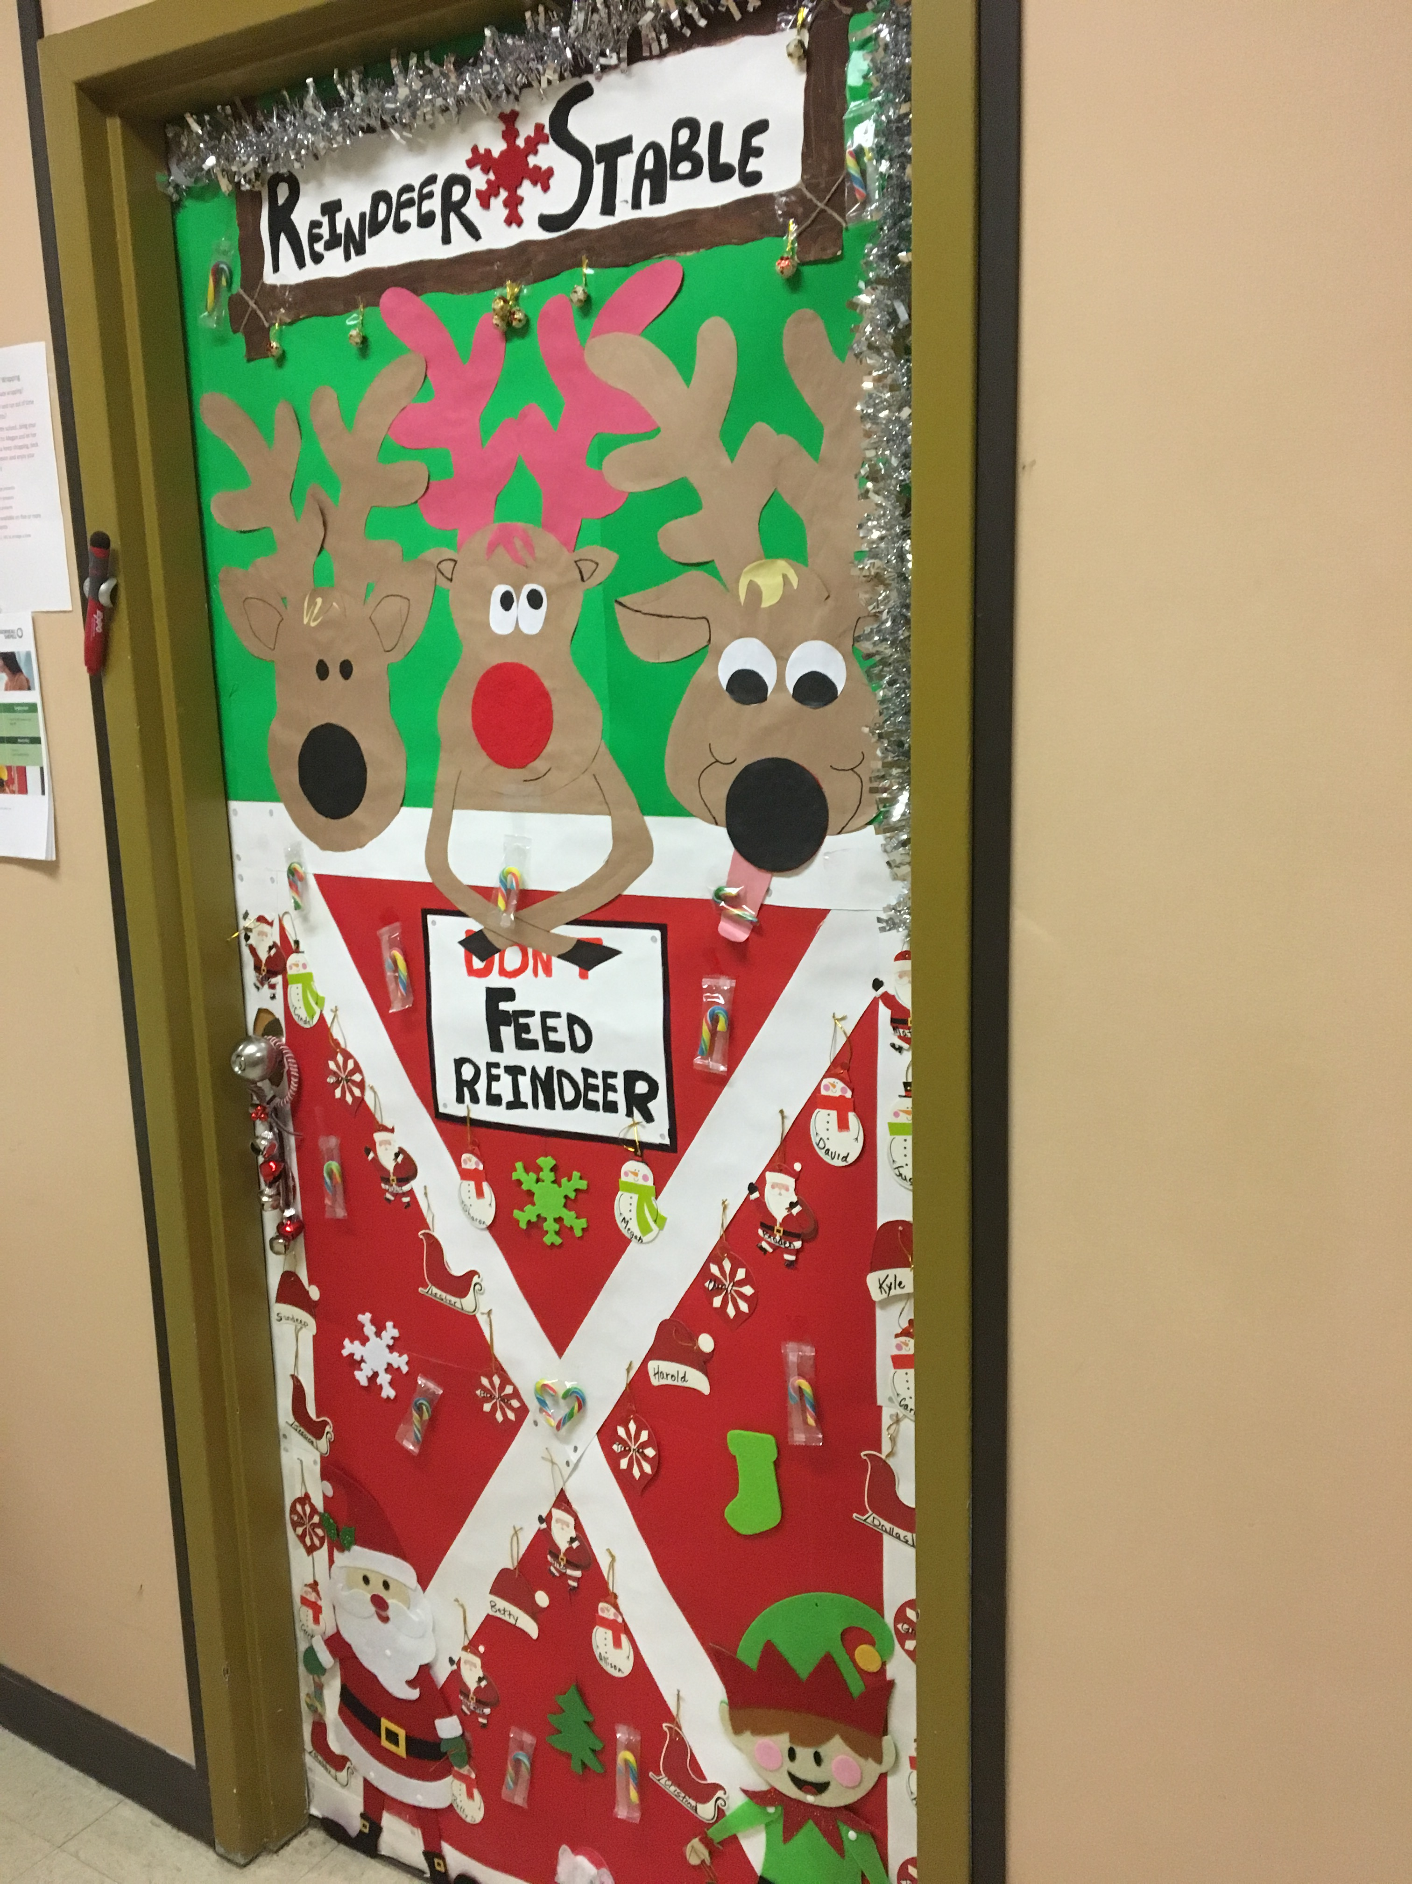

CHILDREN’S CHRISTMAS PARTY
SPAN hosted a children’s Christmas party for the children and grandchildren of SPAN employees. This year’s theme was “Drive In Movie”. The children created their own “vehicles” from cardboard boxes and then enjoyed a movie complete with snacks and a visit from Santa.
There were approximately 67 people in attendance.
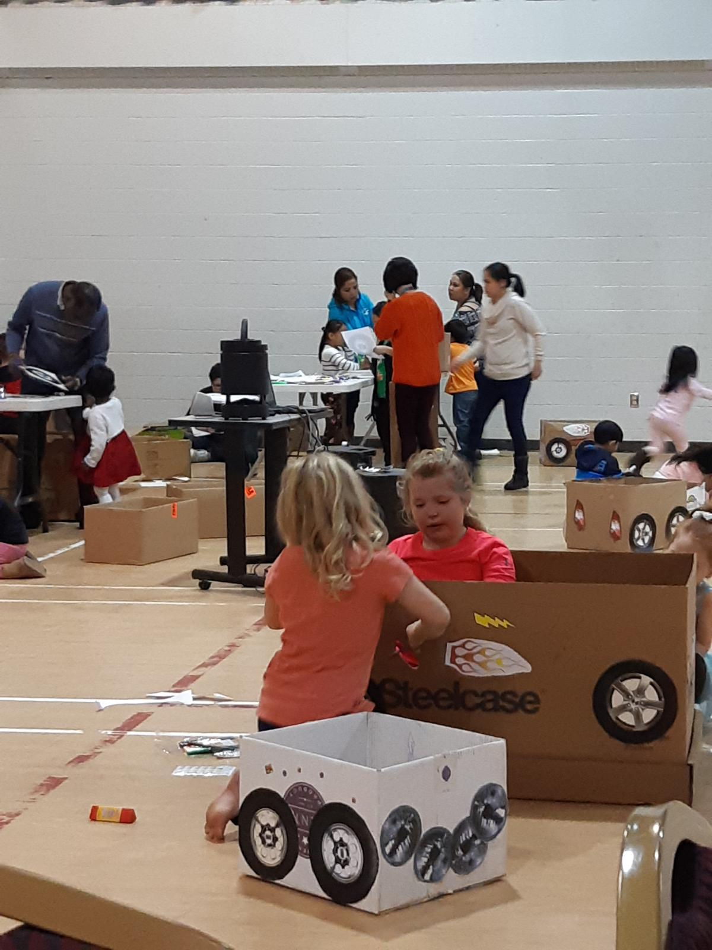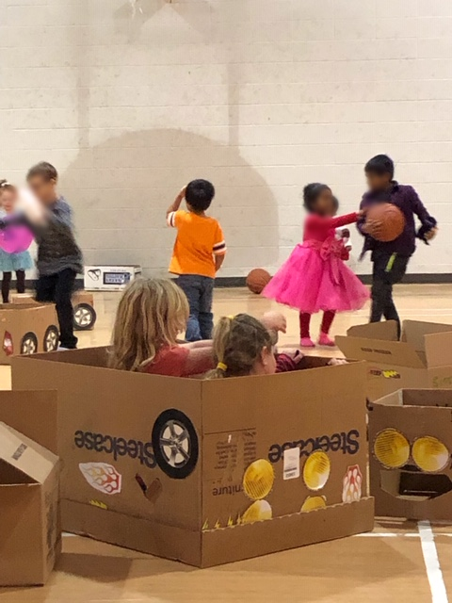



CHRISTMAS LIGHT CONTEST
Each year, SPAN hosts a Christmas light contest for the homes. This year, SPAN had the most decorated yards in the commuity – well done everyone. The staff and individuals seem to enjoy the friendly competiveness of this contest and have their own little tricks of the trade to have the best decorated yard. Congratulations to all the winners.
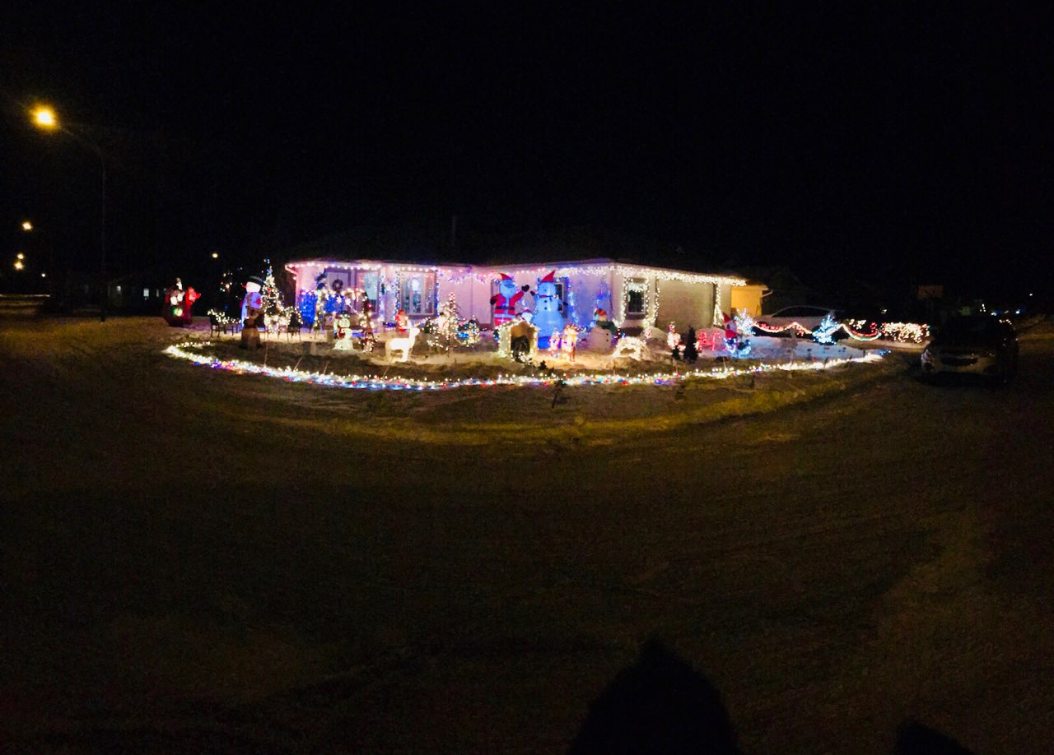
Home 10 – First Place Winner!


Home 5 – Third Place Winner!

Home 12 was second place winner: no photo available

STAFF APPRECIATION
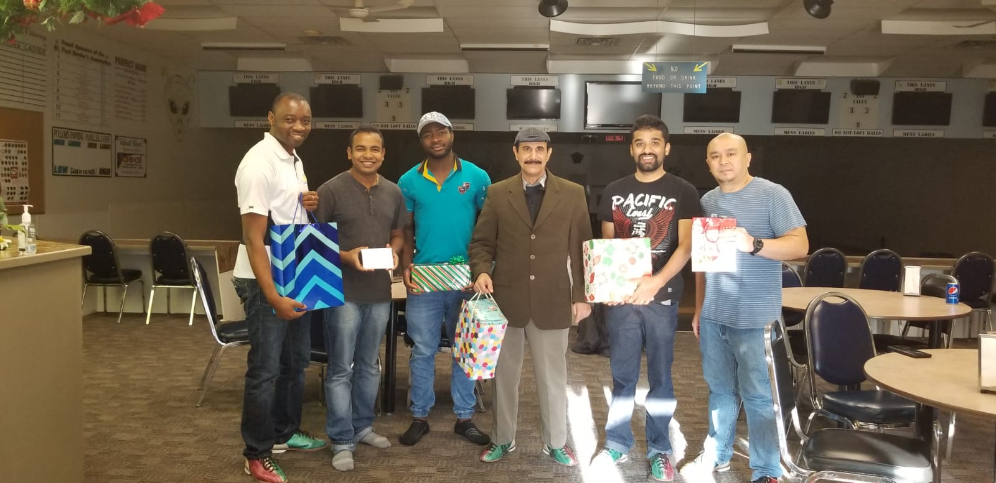
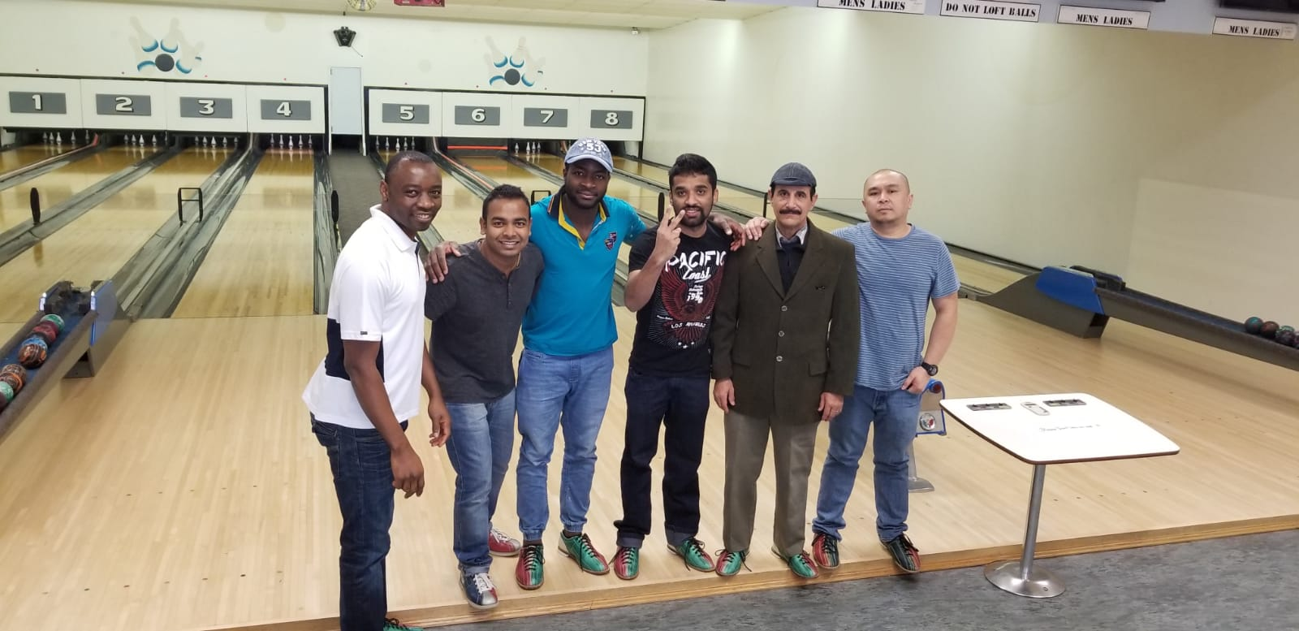
Each year, SPAN provides money toward a staff appreciation event. We are very fortunate to have these funds to show our staff how much we appreciate all their hard work throughout the year. While these funds are available at any time during the year, most events are held during the month of December. Staff appreciation events varied from going out for lunch, gift exchanges, bowling or another fun activity.
Home 17 shared a few photos of their bowling event. The Team Leader stated: “It was an important opportunity for the staff to spend time away from work and build quality relationship with co-workers. A team that works collaboratively and promote healthy employee relationship. It was a fun-filled moment for the team as they enjoyed their time bowling and later had pizza for lunch. The team thank the board of directors for the $100 provided to each home as staff appreciation money. The staff also did a Christmas gift exchange among themselves after eating lunch.”

STAFF WELLNESS
Staff wellness is important; we need to be well to provide quality services to the individuals we serve, provide for our families and be a contributing member in our community. We cannot fill anyone else’s bucket if our own bucket is empty.
The challenge to staff is this; if you complete all 24 items on this challenge list (or something similar to the item/activities), write your name on the top of the challenge post and submit to me by the end of February to have your name entered into a draw for a prize
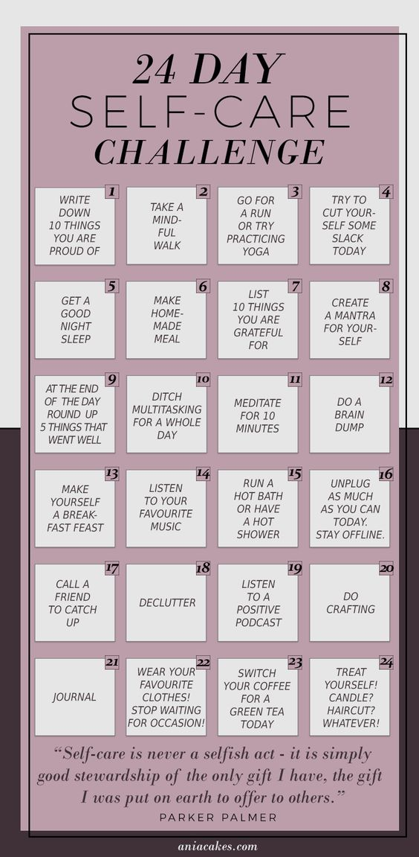

The award winners for the month of December are:
MONTHLY AWARD WINNERS
- Staff of the month: Prince Adjeivi: Prince was chosen because he is willing to, and has covered shifts when asked/needed.
- Volunteer of the month: Braden Campeau: Braden volunteered to play the role of Santa at the Children’s Christmas Party and dressed up as Santa at the Office Christmas Party.
- Team Builder of the month: Wanji Terrance: Wanji has a well-established team within Home 17 and has not had a very high turnover of staff.
- Community Capacity: Cathy and Reggie Mason: Cathy and Reggie volunteer for DAC.



